**Computer Graphics & Animation**

## Solve the following:

## 1-a Basic Functions Used For Graphics In C / C++ / Python Language

**Codes**: -

#include<graphics.h>

#include<conio.h>

void main()

{

int gd = DETECT, gm;

initgraph(&gd, &gm,"C:\\TURBOC3\\BGI");

bar(50,50,150,150);

bar3d(200,50,300,150,20,1);

arc(400,100,0,130,50);

circle(550,100,50);

rectangle(200,250,450,350);

getch();

closegraph();

}

**OUTPUT:-**

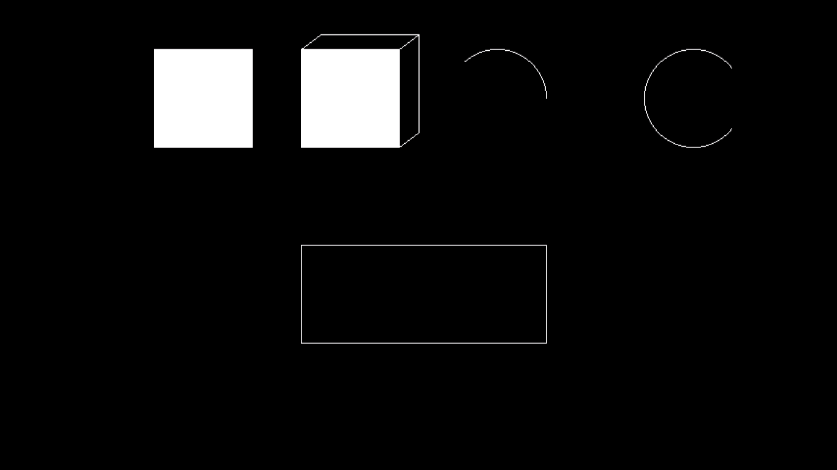

## 1-b Draw A Co-ordinate Axis At The Center Of The Screen

**Codes: -**

#include<stdio.h>

#include<conio.h>

#include<graphics.h>

void main()

{

int gd = DETECT, gm;

int midx, midy;

initgraph(&gd, &gm, "C:\\TURBOC3\\BGI");

cleardevice();

midx=getmaxx()/2;

midy=getmaxy()/2;

line(1,midy,1920,midy);

line(midx,1,midx,1080);

getch();

}

**OUTPUT:**



## 2-a Divide Your Screen Into Four Region, Draw Circle, Rectangle, Ellipse And Half Ellipse In Each Region with appropriate message.

**Code: -**

#include<iostream.h>

#include<stdlib.h>

#include<stdio.h>

#include<graphics.h>

int main()

{

char a[2];

int x,y;

int gd=DETECT,gm;

initgraph(&gd, &gm, "C:\\TURBOC3\\BGI");

x=getmaxx()/2;

y=getmaxx()/2;

line(x,0,x,y);

line(0,y,x,y);

line(x,y,getmaxx(),y);

line(x,y,x,getmaxx());

outtext("Circle");

circle(159,120,80);

outtextxy(320,0,"Rectangle");

rectangle(360,40,580,200);

outtextxy(0,241,"Ellipse");

ellipse(159,360,0,360,50,100);

outtextxy(321,241,"Half Ellipse"); ellipse(529,360,0,180,50,100);

getch();

return 0;

closegraph();

}

## Output: -

## 2-b Draw A Simple Hut On The Screen. Ki

## Code: -

#include<graphics.h>

#include<conio.h>

void main()

{

int gd = DETECT, gm;

initgraph(&gd, &gm, "C:\\TURBOC3\\BGI");

setcolor(WHITE);

rectangle(160,200,240,400);

rectangle(185,250,215,400);

rectangle(240,200,400,400);

line(160,200,200,100);

line(200,100,240,200);

line(200,100,350,100);

line(350,100,400,200);

circle(200,170,15);

getch();

closegraph();

}

**Output**: -

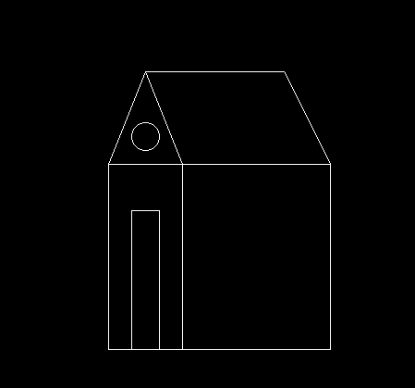

## 3: -Draw The Basic Shapes In The Center Of The Screen

**i. Circle ii. Rectangle iii. Square**

**iv. Concentric Circles v. Ellipse vi. Line**

**Code: -**

1. **Circle in Centre of the Screen:**

#include<graphics.h>

#include<conio.h>

void main()

{

int gd=DETECT,gm;

int x,y,radius=80;

initgraph(&gd,&gm,"C:\\TC\\BGI");

x=getmaxx()/2;

y=getmaxy()/2;

outtextxy(x-100,50,"Circle Using Graphics in C");

circle(x,y,radius);

getch();

closegraph();

}

**OUTPUT:-**

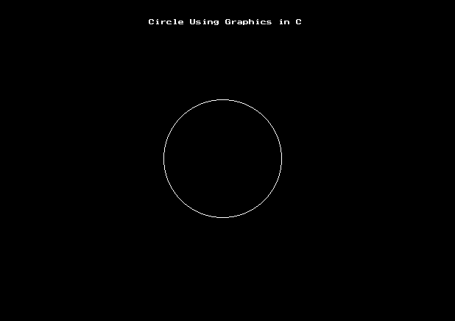

1. **Rectangle in Centre of the Screen:**

#include<graphics.h>

#include<conio.h>

void main()

{

int gd=DETECT,gm;

initgraph(&gd,&gm,"C:\\TC\\ BGI");

rectangle(150,50,400,150);

bar(150,200,400,350);

getch();

closegrap h();

}

**Output:-**

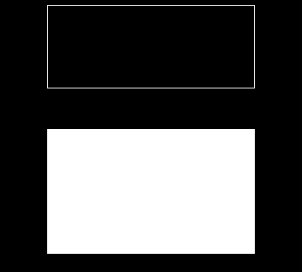

**Concentric Circle in the Centre of the Screen:**

#include<graphics.h>

#include<conio.h>

#include<stdio.h>

#include<math.h>

void main()

{

int rc,rb,xc,yc,i;

float x,y;

int gd=DETECT,gm;

initgraph(&gd,&gm,"C:\\TC\\BGI ");

printf("enter the radiusofthe outercircle\n");

scanf("%d",&rc);

printf("enter the radius of the innercircle\n");

scanf("%d",&rb);

printf("enter the center of the circle\n");

scanf("%d",&xc);

scanf("%d",&yc);

for(i=1;i<=360;i++)

{

x=xc+(rb*(cos (i)));

y=yc+(rb*(sin (i)));

putpixel(x,y,7);

}

for(i=1;i<=360;i++)

{

x=xc+(rc*(cos(i)));

y=yc+(rc*(sin(i)));

putpixel(x,y,7);

}

getch();

closegrap h();

}

**Output:-**

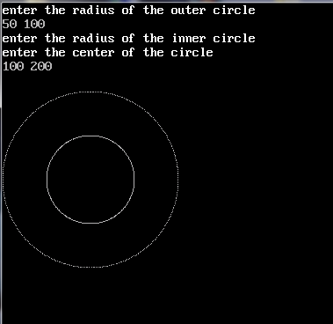

**Ellipse Circle inCentre of the Screen:**

#include<graphics.h>

#include<conio.h>

void main()

{

int gd=DETECT,gm; int x,y;

initgraph(&gd,&gm,"C:\\TC\\BGI");

x=getmaxx()/2;

y=getmaxy()/2;

outtextxy(x-100,50,"ELLIPSE Using Graphics in C");

ellipse(x,y,0,360,120,60);

getch();

closegraph();

}

**Output:-**

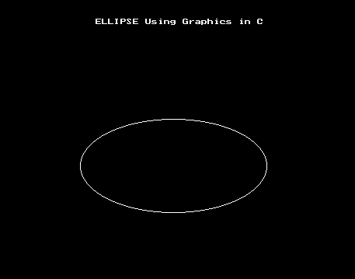

**Line Circle in Centre of the Screen:**

#include<graphics.h>

#include<stdio.h>

#include<conio.h>

void main()

{

int gd=DETECT,gm;

int x1=200,y1=200;

int x2=300,y2=300;

initgraph(&gd,&gm,"C:\\TC\\BGI");

line(x1,y1,x2,y2);

getch();

closegraph();

}

**Output: -**